Lab: Linear Data Structures
Problems for exercises and homework for the "Data Structures" course @ SoftUni.
You can check your solutions here: https://judge.softuni.bg/Contests/Compete/Index/550#0.

ArrayList<T>
Implement a data structure ArrayList<T> that holds a sequence of elements of generic type T. It should hold a sequence of items in an array. The structure should have capacity that grows twice when it is filled, always starting at 2. The list should support the following operations:
- int Count returns the number of elements in the structure
- T this[int index] the indexer should access the elements by index (in range 0 … Count-1) in the reverse order of adding
- void Add(T item) adds an element to the sequence (grow twice the underlying array to extend its capacity in case the capacity is full)
- T RemoveAt(int index) removes an element by index (in range 0 … Count-1) and returns the element
Be sure to test implemented operations whenever possible before moving to the next

Examples
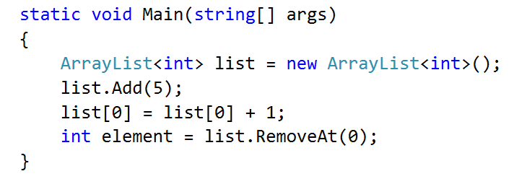

Solution
Declare the class ArrayList<T>
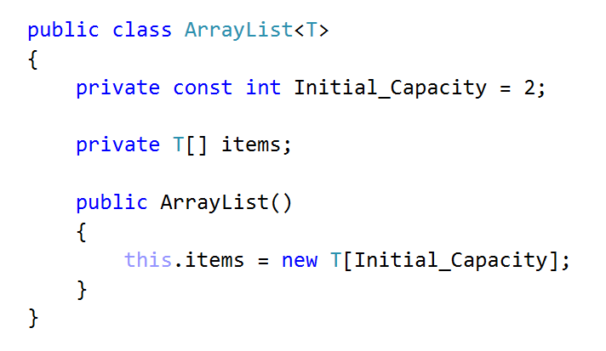
Start with Count and Indexer
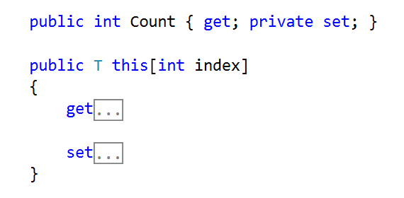
Implement get by index
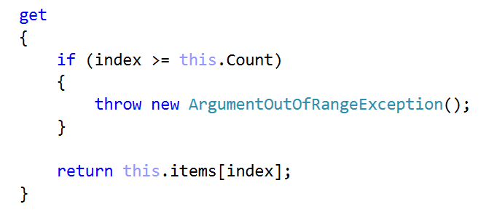
And set by index should be
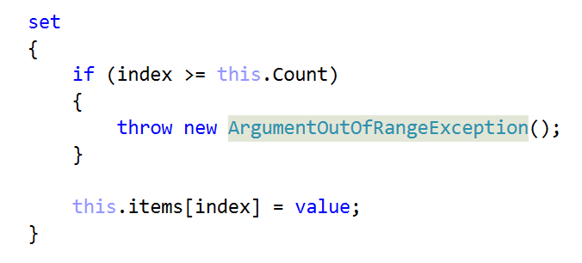
Implement Add and Resize methods
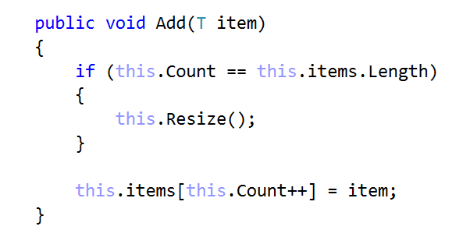
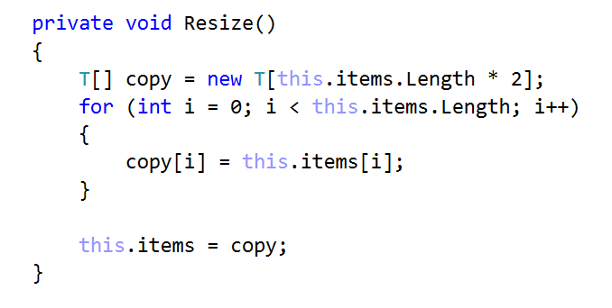
Finally, implement RemoveAt, Shrink and Shift methods
